**Bug on Page ‘www.bonify.de​’:**

**Issues 2:**

On '**https://www.bonify.de/datenschutz**', Page when I change from DE to EN, PDF are still downloading in DE not in EN.

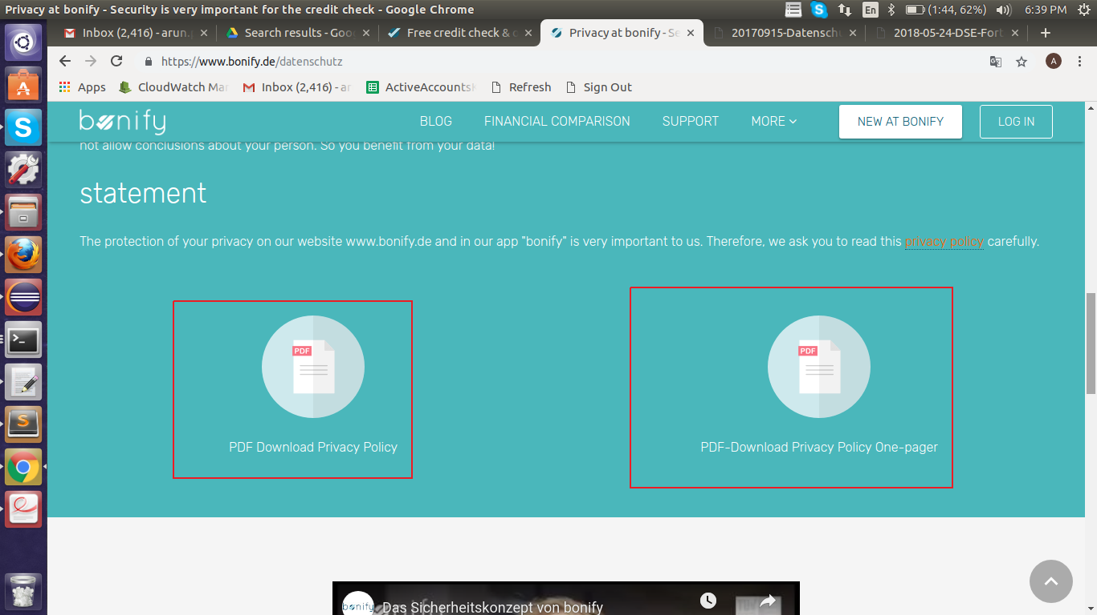

**Steps To Reproduce:**

1: Start Chrome Browser with url **‘**[**https://www.bonify.de/**](https://www.bonify.de/)**’.**

2: Then Under ‘More’ click on ‘Data Protection’.

3: Then Scroll down to page and locate PDF Download section.

**Expected Result:** When the site is on EN the PDF should be downloaded in English.

**Actual Result:** The PDF is downloading in DN although the site is converted to EN.

**Browser:** Chrome (Version 70)

**OS:** Ubuntu (16)

**Priority:** P2

**Assign To :** Developer.

